SQL Server - Linked Servers

The Linked Servers option allows you to connect to another instance of SQL Server running on a different machine, perhaps remotely in a different city/country. This can be useful if you need to perform distributed queries (query a remote database). Setting up a linked server is quite straight forward in SSMS, all you need is details of the remote server, and the database that you need to query.

## Creating a Linked Server

To create a linked server:

1. Navigate to *Server Objects > Linked Servers*
2. Right click on *Linked Servers* and select *New Linked Server...*. Like this:  
   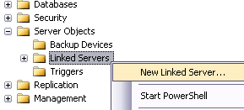
3. Complete the details for the linked server. In this example, *Data source* refers to the name of the SQL Server machine ("Barts_database_server"), *Catalogue* refers to the name of the database ("Barts_database"). You can also configure options in the other two tabs depending on your requirements.  
   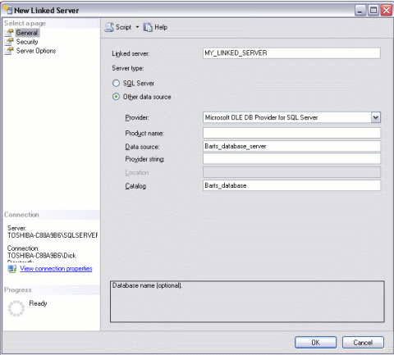

## Distributed Queries

Once you have configured your linked server, you will be able to run queries etc against it. When you run a query against a linked server, it is referred to as a *distributed query*.

When you execute a distributed query against a linked server, you must include a fully qualified, four-part table name for each data source to query. This four-part name should be in the form *linked_server_name.catalog.schema.object_name*.

Here's an example:

Barts_database_server.Barts_database.Person.Enemy

This example is based on the linked server example above. It assumes that the remote database has a schema called "Person" and a table called "Enemy".